CS 250 Spring 2017 - Lab 03

Due in lab Feb. 07-10, 2017

Submit your typewritten file in PDF format to Blackboard

**Questions**

1. [15 points; 5 points for each for result] Does the timing of the 555 clock output match the predictions of the equations for frequency, t_high, and t_low that are given below the schematic? Show a calculation of the expected value for each of the three parameters..

Frequency = $1/(ln\left(2\right)* C2*(R1+2*R2))=$

= 1 / (ln(2) * 0.001F * (470Ω + 2 * 470Ω)) = **1.023 Hz**

t_high = ln(2) * (R1 + R2) * C2

= ln(2) * (470Ω + 470Ω) * 0.001F = **0.6516 seconds**

t_low = ln(2) * R2 * C2

= ln(2) * 470Ω * 0.001F = **0.3258 seconds**

1. [10 points] The 74HC163 is a 4-bit counter, but this lab needs only a 3-bit counter. How can you obtain a 3-bit counter from the output of a 4-bit counter? Which three of the output signals would you select and why?

You can obtain a 3-bit counter from the output of a 4-bit counter by simply excluding the most significant bit. We would select the three output signals of the three least significant bits. This works because in a 4-bit sequence the 3 least significant bits just repeat (if ignoring the most significant bit), thus acting like a 3-bit counter.

1. Derive the Boolean expressions for each color of the stoplight, and simplify in terms of 2-input NAND and NOR gates. Show your work to earn credit. Your Boolean expression must be in terms of QA, QB, QC, and QD, for the counter outputs, and/or D0 – D7 for the eight decoder/demux outputs. Draw the final schematic diagram using NAND and NOR gates for each color.
   1. [10 points] Green light Boolean expression and schematic.

|  |  |  |  |
| --- | --- | --- | --- |
| Qc | Qb | Qa | Output |
| 0 | 0 | 0 | 1 |
| 0 | 0 | 1 | 1 |
| 0 | 1 | 0 | 1 |
| 0 | 1 | 1 | 0 |
| 1 | 0 | 0 | 0 |
| 1 | 0 | 1 | 0 |
| 1 | 1 | 0 | 0 |
| 1 | 1 | 1 | 0 |

Qc Qb

Qa

00 01 11 10

0

1

|  |  |  |  |
| --- | --- | --- | --- |
| 1 | 1 | 0 | 0 |
| 1 | 0 | 0 | 0 |

K-Map: Qc’Qb’ + Qc’Qa’

NAND: ((Qc’Qb’)’ * (Qc’Qa’)’)’

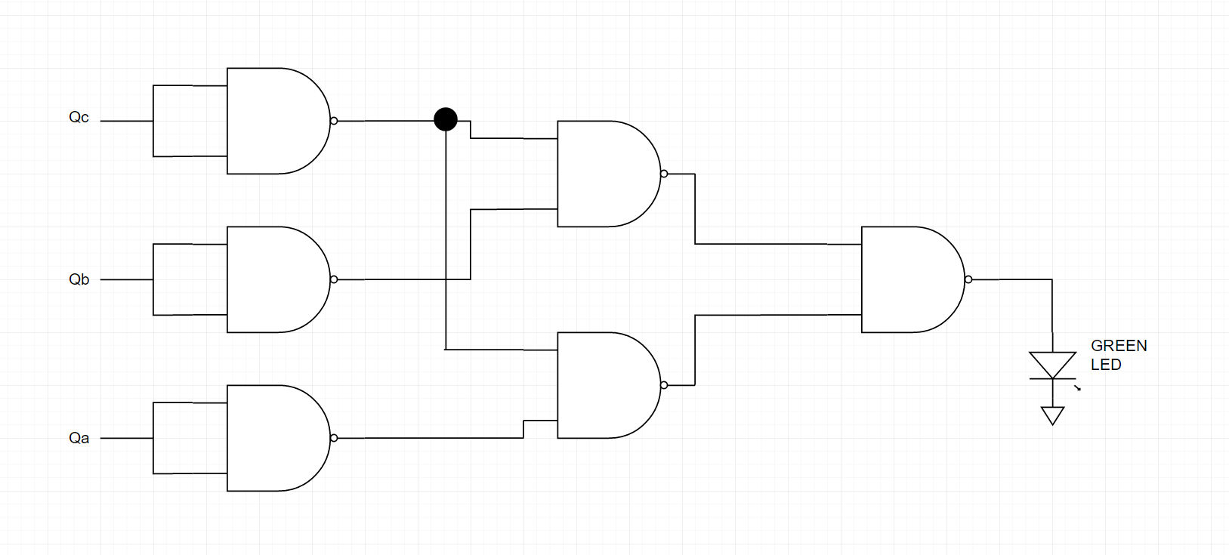

* 1. [10 points] Yellow light Boolean expression and schematic.

|  |  |  |  |
| --- | --- | --- | --- |
| Qc | Qb | Qa | Output |
| 0 | 0 | 0 | 0 |
| 0 | 0 | 1 | 0 |
| 0 | 1 | 0 | 0 |
| 0 | 1 | 1 | 1 |
| 1 | 0 | 0 | 0 |
| 1 | 0 | 1 | 0 |
| 1 | 1 | 0 | 0 |
| 1 | 1 | 1 | 0 |

Qc Qb

Qa

00 01 11 10

0

1

|  |  |  |  |
| --- | --- | --- | --- |
| 0 | 0 | 0 | 0 |
| 0 | 1 | 0 | 0 |

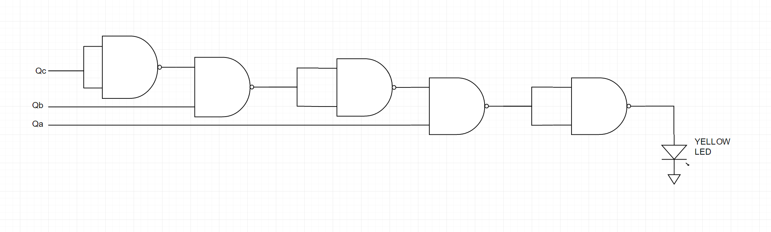

* 1. [10 points] Red light Boolean expression and schematic drawing of gates.

|  |  |  |  |
| --- | --- | --- | --- |
| Qc | Qb | Qa | Output |
| 0 | 0 | 0 | 0 |
| 0 | 0 | 1 | 0 |
| 0 | 1 | 0 | 0 |
| 0 | 1 | 1 | 0 |
| 1 | 0 | 0 | 1 |
| 1 | 0 | 1 | 1 |
| 1 | 1 | 0 | 1 |
| 1 | 1 | 1 | 1 |

Qc Qb

Qa

00 01 11 10

0

1

|  |  |  |  |
| --- | --- | --- | --- |
| 0 | 0 | 1 | 1 |
| 0 | 0 | 1 | 1 |

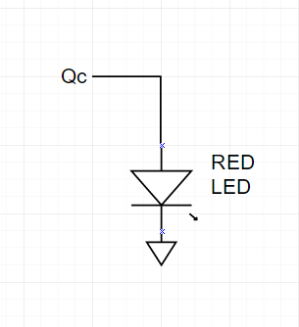

1. Demonstrate your circuit to your TA. Full credit when the order and timing of lights is correct.
   1. [15 points] Green light turns on for 3 seconds, then
   2. [15 points] Yellow light turns on for 1 second, then
   3. [15 points] Red light turns on for 4 seconds.